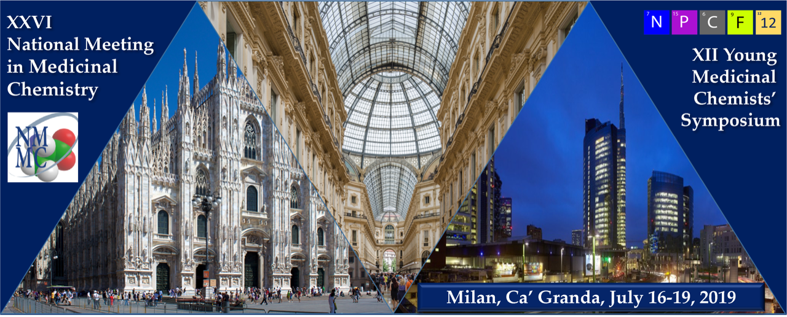

Please indicate the preference between oral communication and poster

Oral communication
Poster

Please select the main topic for your abstract as taken from https://nmmc2019.unimi.it/topics/

Submit the abstract by email to nmmc2019@unimi.it

The deadline for abstract submission is 31st May 2019

USE UPPER CASE CALIBRI 12 POINTS BOLD FOR ABSTRACT TITLE
[max. 2 lines]
(double space)

Last name, N.;ª Last name, N.;^{b} ………and Last name, N.^{c,} [calibri 11]
(First name initials and last names of all authors; presenting author name should be underlined)
(one space)
ª Affiliation; ^{b} Affiliation; ^{c} Affiliation. [calibri 11, Italic]
(Affiliations should be written as Institution name, Full postal address, Country)
E-mail of the presenting author: e-mail@address.org [calibri 11]
(double space)

Body of the text: calibri 11 points with single spacing for body text. Justified alignment.

References should be numbered in the sequence and referred with Arabic numbers in superscript.^{1,2}
Please do not use any automatic tool for inserting references.

Figures, schemes and tables may be inserted, provided that they are referenced in the abstract text and that they bear an appropriate caption formatted as follows:

Figure 1, Table 1, Scheme 1. [calibri 9]

For drawing chemical structures, we advise to use ChemDraw (use Object settings ACS) or ISIS Draw. Insert Object in Word and resize object to 70%.

The abstract body, including figures, schemes, tables and references must not exceed one page.

References
Use Calibri 9 points for references. References should be placed at the end of the text and numbered in the sequence in which they appear in the text. Do not use automatic numbering.

1. Clark, R. B.; Lamppu, D.; Libertine, L.; McDonough, A.; Kumar, A.; LaRosa, G.; Rush, R.; Elbaum, D. J. Med. Chem. 2014, 34, 3966-3983.

