3rd SITELF National PhD Summer School – XXV ADRITELF National PhD School
Simulations and in vitro/in vivo methods for testing your delivery systems
September 29th, 2026 – October 1st, 2026
Flamingo Resort, Pula (CA) - SARDINIA

Venue and accomodation
The summer school will be held at the Wild Duck congress center, located within the premises of the Flamingo Resort Hotel (Santa Margherita di Pula, Cagliari). For the convenience of the participants, accommodation will be provided at the Mare Pineta Hotel, located just a five-minute walk from the congress venue, connected by a scenic path through the resort's private park.

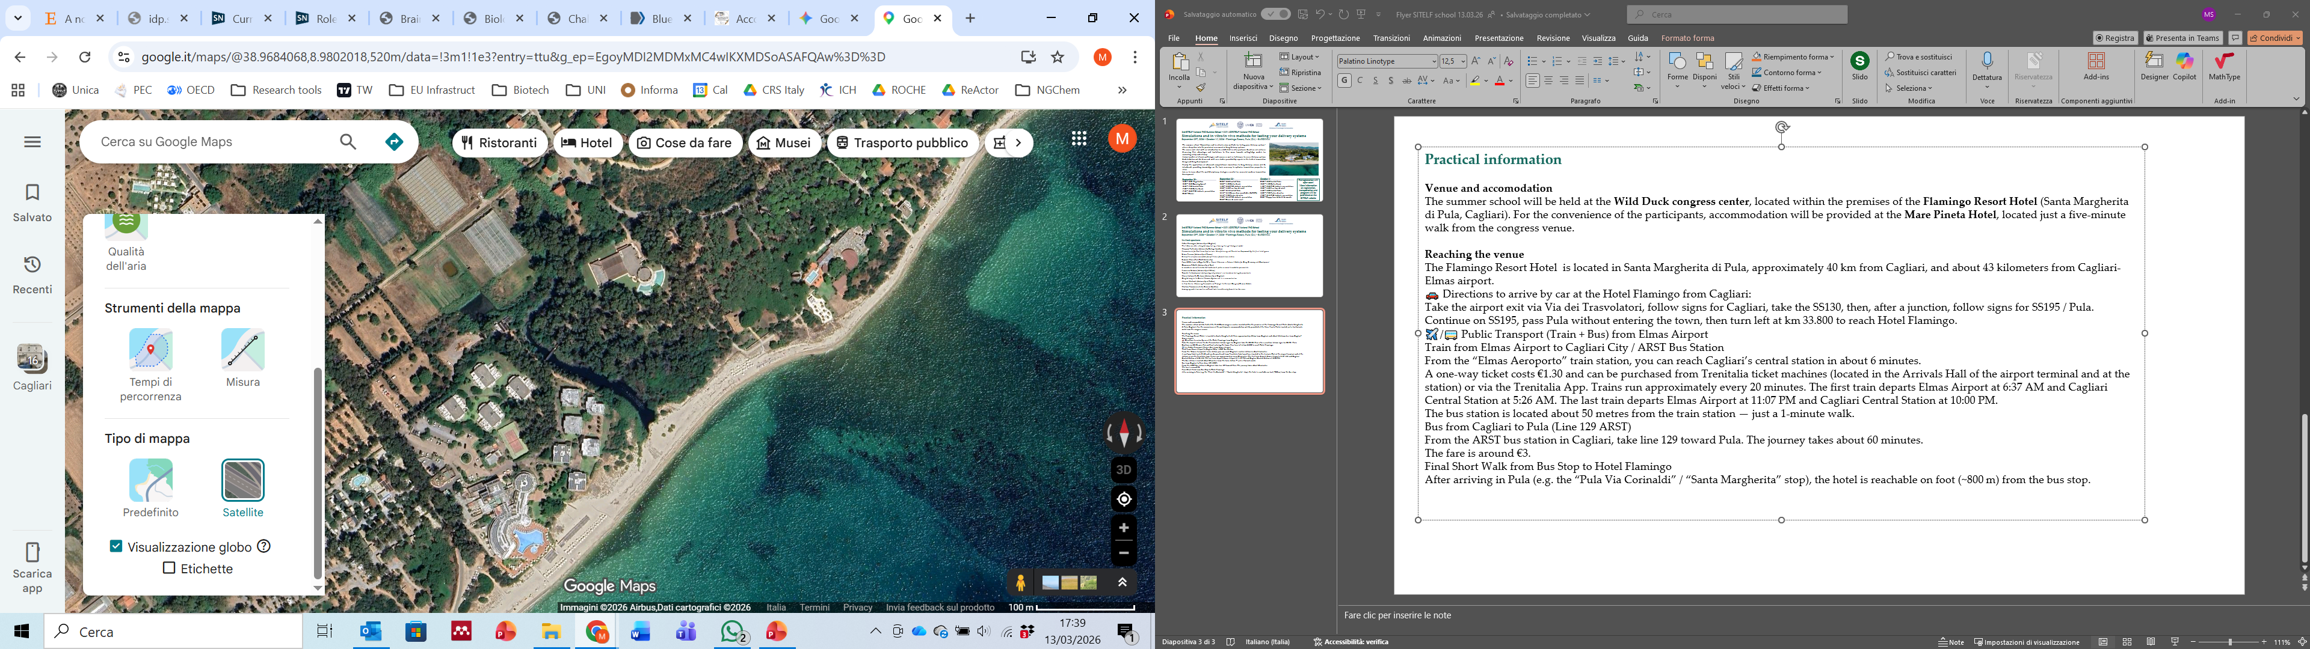
Wild Duck congress center
Mare Pineta Hotel
Flamingo Resort Hotel

Reaching and leaving the venue
The Flamingo Resort Hotel is located in Santa Margherita di Pula, approximately 40 km from Cagliari and from Cagliari-Elmas airport.
By collective transfer
Transfers have been organized for those who made requests through the online form. A confirmation email with the time of your transfer was sent on September 20th.
By public transport from Elmas Airport
Trains connect Elmas Airport to Cagliari central station in about 6 minutes. A one-way ticket costs €1.30 and can be purchased from Trenitalia ticket machines. Trains run approximately every 20 minutes. The first train departs Elmas Airport at 6:37 AM and Cagliari Central Station at 5:26 AM. The last train departs Elmas Airport at 11:07 PM and Cagliari Central Station at 10:00 PM.
Once in Cagliari, the bus station is located about 50 metres from the train station.
From the ARST bus station in Cagliari, take line 129 (direction: Santa Margherita di Pula). The journey takes about 60 minutes and the fare is around €3.
After arriving at Santa Margherita stop, the Flamingo Resort is reachable by walk (~800 m) from the bus stop.
For additional information, visit the ARST bus network website - https://www.arst.sardegna.it/servizi-orari/servizi-extraurbani
Certificate of participation
The certificates of participation will be sent by email at the end of the event.

